Code Fury

Software Design Description (SDD)

Contents

1 Scope 3

1.1 Identification 3

1.2 System overview 3

1.3 Document overview 3

2 Referenced documents 3

3 CSCI-wide design decisions 3

4 CSCI architectural design 5

4.1 CSCI components 5

4.2 Concept of execution 8

4.3 Interface design 8

5 CSCI detailed design 9

5.1 Value range descriptions and database sources 9

6 Requirements traceability 10

# 1 Scope

## Identification

This document pertains to system version 1.0.0.

## System overview

This system aims to provide users with an interactive map of the United States marked with areas that satisfy their lifestyle preferences.

## Document overview

This document provides an itemization of system-wide design decisions. A system-wide design decision is a decision about any of the following:

* Architectural design
* Component design
* Interface design
* Database configuration
* Behavioral constraints

Additionally, brief descriptions are given alongside each decision.

# Referenced documents

The following is a list of documents that this document refers to.

* Software Requirements Specification (SRS)

# CSCI-wide design decisions

The following is an itemization of legal inputs and their respective outputs. Handling of illegal input combinations are also described. Each input is associated with a unique interface component id. These components are described in detail in the interface design section of this document.

* Input: Public school button switched to on position and ranking selected. Output: Results of search query filtered on public school ranking selected and any other selected criteria displayed as pins (or possibly clusters of pins) on the map display. If the user does not select a ranking from the dropdown menu, the search will default to filtering on a low ranking. Additionally, the button’s state will be displayed in the active options bar above the map display.
* Input: Public transportation button switched to on position and level of availability selected. Output: Results of the search query filtered on level of availability selected and any other selected criteria displayed as pins (or possibly clusters of pins) on the map display. If the user does not select a level of availability from the dropdown menu, the search will default to filtering on a low level of availability. Additionally, the button’s state will be displayed in the active options bar above the map display.
* Input: Crime button switched to on position and crime rate selected. Output: Results of search query filtered on crime rate selected and any other selected criteria displayed as pins (or possibly clusters of pins) on the map display. If the user does not select a crime rate from the dropdown menu, the search will default to filtering on a low crime rate. Additionally, the button’s state will be displayed in the active options bar above the map display.
* Input: Outdoor recreation button switched to on position and activity button(s) switched to on position. Output: Results of search query filtered on all activities with buttons switched on and any other selected criteria displayed as pins (or possibly clusters) on the map display. All activity buttons are switched on by default. Additionally, the outdoor recreation button’s state will be displayed in the active options bar above the map display.
* Input: Climate button switched to on position, climate type selected, level of precipitation selected, and level of snowfall selected. Output: Results of search query filtered on climate type selected, level of precipitation selected, level of snowfall selected and any other selected criteria displayed as pins (or possibly clusters of pins) on the map display. If the user does not select climate, precipitation, or snowfall conditions from the dropdown menu, the search will default to filtering on no climate preference, low level of precipitation, and low level of snowfall. Additionally, the button’s state will be displayed in the active options bar above the map display.
* Input: Health care button switched to on position and ratio of doctors to patients selected. Output: Results of search query filtered on ratio of doctors to patients selected and any other selected criteria displayed as pins (or possibly clusters of pins) on the map display. If the user does not select a doctor to patient ratio from the dropdown menu, the search will default to filtering on an average doctor to patient ratio. Additionally, the button’s state will be displayed in the active options bar above the map display.
* Input: Commute time button switched to on position and average time slider set. Output: Results of search query filtered on average commute time selected and any other selected criteria displayed as pins (or possibly clusters of pins) on the map display. If the user does not change the position of the average time slider, a default average time of 60 minutes will be used. Additionally, the button’s state will be displayed in the active options bar above the map display.
* Input: Zoom between country, state, and county level. Output: Map display will switch to state level if zooming in from country level or county level if zooming in from state level. Conversely, map display will switch to state level if zooming out from county level or country level if zooming out from state level. If the user attempts to zoom out from country level or zoom in from county level, nothing will happen. If pins are clustered (this happens when too many pins are placed in a small area), zooming in will reveal the pins that comprise the cluster. Conversely, zooming out will re-cluster any pins that were previously clustered.
* Input: Click on a cluster. Output: The map display will switch to a level that is appropriate for viewing the individual pins that comprise the cluster.
* Input: Hover over pin. Output: Information about why that area meets the users search criteria will be displayed.

# CSCI architectural design

## CSCI components

The following is an itemization of all software components. A brief description of each component is given along with a unique component identifier. If a component is assigned an identifier elsewhere (in another document), that identifier will be used in this section as well. Identifiers for interface components begin with an I, while identifiers for database and API components begin with D and A respectively. Additionally, identifiers for routine/subroutine and language components begin with R.

* (I1) The map display. This is where the search results are displayed. More specifically, locations that match the search criteria are overlaid with pins or clusters of pins. Hovering over pins will give specific values for search criteria. Clicking on a cluster will zoom map display to a level appropriate for viewing all pins that comprise that cluster.
* (I2) The active options bar. This component is located above the map display. It lists the filters that are currently selected (For example, if the public schools button is switched to on, this will be indicated in the active options bar).
* (I3) The side menu hamburger button. This component is located above the map display to the left of the activity options bar. When pressed the options menu will slide out to the left of the map display. If the options menu is open and the 'X' button is pressed, the menu will disappear.
* (I4) The options menu. This component is a container for the search filters described in the interface design section of this document.
* (I5) The public schools button. This component controls filtering by public school availability.
* (I6) The school ranking dropdown menu. This component allows the user to narrow the search by school ranking. There are three possible school rankings, namely low, medium, and high. More information about these values can be found in the detailed design section of this document.
* (I7) The public transportation button. This component controls filtering by public transportation availability.
* (I8) The transportation availability dropdown menu. This component allows the user to narrow the search by level of transportation availability. There are three possible levels, namely low, medium, and high. More information about these values can be found in the detailed design section of this document.
* (I9) The crime button. This component controls filtering by crime rate.
* (I10) The crime rate dropdown menu. This component allows the user to narrow the search by crime rate. There are two possible levels, namely low and average. More information about these values can be found in the detailed design section of this document.
* (I11) The outdoor recreation button. This component controls filtering by outdoor recreation availability.
* (I12) The activity buttons. These components allow the user to narrow the search by availability of activities. There are seven possible activities to filter by, namely hiking, climbing, camping, biking, swimming, wilderness, and hunting. More information about these values can be found in the detailed design section of this document.
* (I13) The climate button. This component controls filtering by climate conditions.
* (I14) The climate preference dropdown menu. This component allows the user to narrow the search by climate type. There are three possible preferences, namely no preference, hotter climate, and colder climate. More information about these values can be found in the detailed design section of this document.
* (I15) The annual precipitation dropdown menu. This component allows the user to narrow the search by amount of annual precipitation. There are three possible amounts of precipitation to select from, namely low, medium, and high. More information about these values can be found in the detailed design section of this document.
* (I16) The annual snowfall dropdown menu. This component allows the user to narrow the search by amount of annual snowfall. There are three possible amounts of snowfall to select from, namely low, medium, and high. More information about these values can be found in the detailed design section of this document.
* (I17) The health care button. This component controls filtering by the availability of quality health care.
* (I18) The doctor to patient ratio dropdown menu. This component allows the user to narrow the search by the average number of doctors to patients. There are two possible levels to select from, namely average number of doctors to patients and high number of doctors to patients.
* (I19) The commute time button. This component controls filtering by average commute time in minutes.
* (I20) The commute time value slider. This component allows the user to narrow the search by setting a commute time threshold value. The range of legal commute time values is zero minutes to 60 minutes. More information about these values can be found in the detailed design section of this document.
* (D1) The RIDB recreation database. The RIDB recreation database contains information about recreation centers and their respective zip codes. This database is used to allow filtering on availability of outdoor recreation activities.
* (D2) The NOAA weather database. The NOAA weather database contains information about climate conditions in various areas of the country. This database is used to allow filtering on climate conditions.
* (A1) The datausa.io API. The datausa.io API is used to retrieve information for filtering on public school ranking, public transportation availability, commute time, crime rate, and quality of health care.
* (A2) The Google Maps API. The Google Maps API is used to construct the map display and display results.
* (R1) Interface will submit a JSON request, with scope (either state or county, as well as a latitude and longitude for the center of the map, plus a bounds tuple (discussed further in (R3)) and search criteria (associative array of active items to search with specific criteria of each search, as appropriate)
* (R2) Controller file will receive request, parse, and call scope model to retrieve array of desired ids to query against. After scope is defined, relevant models to execute desired searches will be called.
* (R3) Scope model will retrieve a single string parameter, either “state” or “county” as well as a latitude and longitude (representing the center of a search), and a bounds tuple which will be the +x, +y from that center to reach the maximum latitude and longitude currently displayed.
* (R4) DataUSA model will handle all requests for items from (A1). The scope will be sent to the model, after a search is executed for all items in scope, any entries that are not matches will be unset from the scope array. This pruned array will be returned for any further processing.
* (R5) Climate and Recreation Model will handle requests for climate and outdoor recreation data. A final scope array will be returned to the controller for final parsing.
* (R6) The controller will call the scope model again, to convert the final pruned scope array into latitude and longitude points. These points are then returned to the interface.
* (R7) The interface will receive a response in the form of a JSON array of latitude and longitude points, which will be used to drop google map API pins onto the map, representing matches.

## Concept of execution

The software components detailed in the section above will interact with each other as described by (R1) - (R7).

## Interface design

The following is an itemization of interface components and detailed descriptions of their respective behavior. The expected outputs of interacting with each component are given in the system-design section. Hence, they have been omitted from this section.

* The on/off buttons. When pressed an on/off button will move to whatever position it is not currently in. That is, if it is in the off position, pressing it will move it to the on position and *vice versa*. When a button is in the on position further options are displayed that allow the user to narrow the search by additional conditions. Search results will then be filtered by whatever buttons are in the on position at the time of searching.
* The commute time slider. The commute time slider is used to narrow the search to within a commute time threshold value. The user will drag the slider to the desired value. Search results will then be narrowed to areas with average commute times less than that threshold value.
* The side menu button. When the side menu button is pressed, the options menu will be revealed. If it is pressed again the side options menu will be hidden.
* Zooming. Zooming between country, state, and county level will be controlled by the mouse wheel. Note: It can also be controlled by clicking the +/- buttons in the lower right-hand corner of the map display.

The following is a diagram of interface components and their layout.

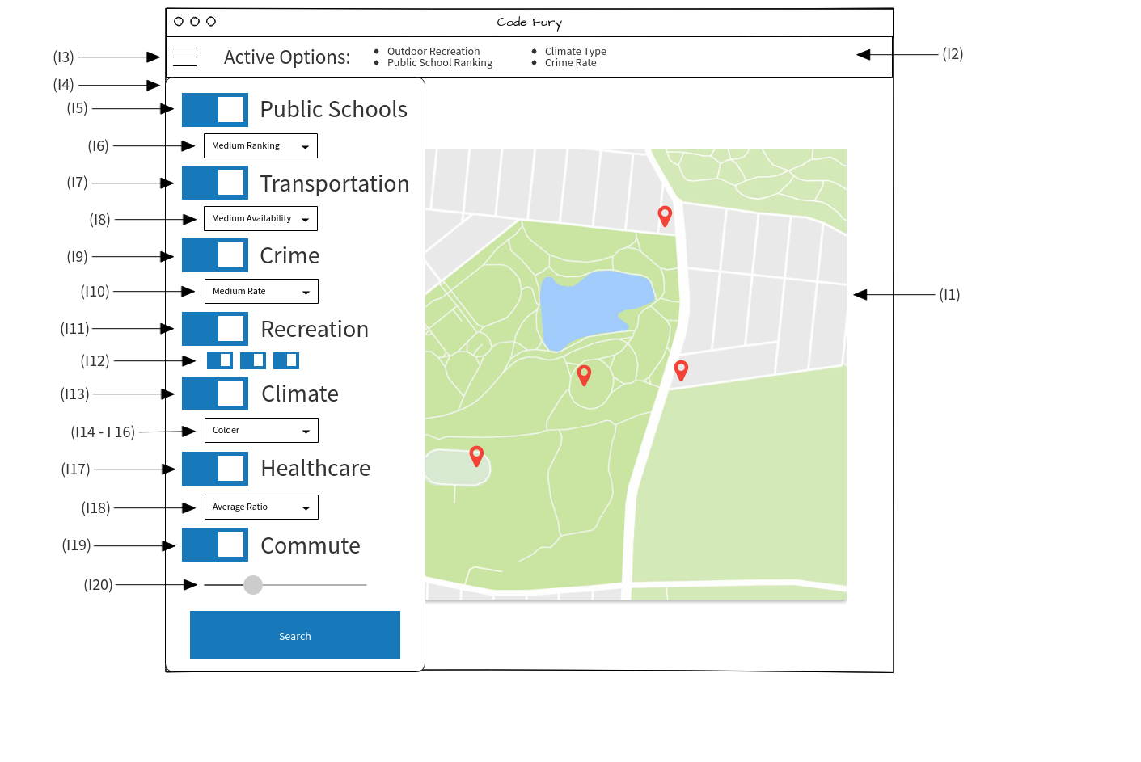

# CSCI detailed design

## Value range descriptions and database sources

## The following is an itemization of interface requirements whose dropdown conditions correspond to specific ranges and descriptions of those ranges.

* (I10) Crime rates. Dropdown conditions for this component use violent crime as defined by the FBI normalized on a scale of 0 to 100, with 0 being the safest and 100 being the most dangerous.
* (I15 & I16) Average precipitation value. Dropdown conditions for this component use values in the range [5, 200]. These values are taken to be inches of precipitation in one year.
* (I20) Commute time threshold value. The range of acceptable values for this component is [0,60]. This value is taken to be minutes per commute.

The following is a list of sources for the databases and API’s used.

* RIDB Recreation Data: <https://ridb.recreation.gov/>
* NOAA Climate Data: <https://catalog.data.gov/dataset/u-s-daily-climate-normals-1981-2010>
* DataUSA <https://datausa.io/>

# Requirements traceability

# The following is a record of the CSCI requirements and their associated software units as identified above; in addition, some traceability is included retroactively in 4.1.

* (I1) Map display; SRS 2.1.3
* (I2) Active Options Bar; SRS 2.1.1.4 - 2.1.1.10
* (I3) Side Menu Button; 4.1
* (I4) Options Menu; 4.1
* (I5) Public Schools Button; SRS 2.1.1.4
* (I7) Public Transportation Button; SRS 2.1.1.5
* (I8) Transportation Accessibility Value; 4.1
* (I9) Crime Button; SRS 2.1.1.6
* (I10) Crime Rate Value; 4.1
* (I11) Outdoor Recreation Button; SRS 2.1.1.7
* (I12) Activity Buttons; 4.1
* (I13) Climate Button; SRS 2.1.1.8
* (I15) Average Precipitation Value; 4.1
* (I17) Health Care Button; SRS 2.1.1.9
* (I19) Commute Time Button; 4.1
* (I20) Commute Time Value; SRS 2.1.1.10
* (D1) RIDB Recreation Database; 4.1, 5.1
* (D2) The NOAA Weather Database; 4.1, 5.1
* (A1) datausa.io API; 4.1
* (A2) Google Maps API; 4.1
* (R1) MySQL; 4.1
* (R2) Controller File; 4.1
* (R3) JSON Data Structures; 4.1